Data

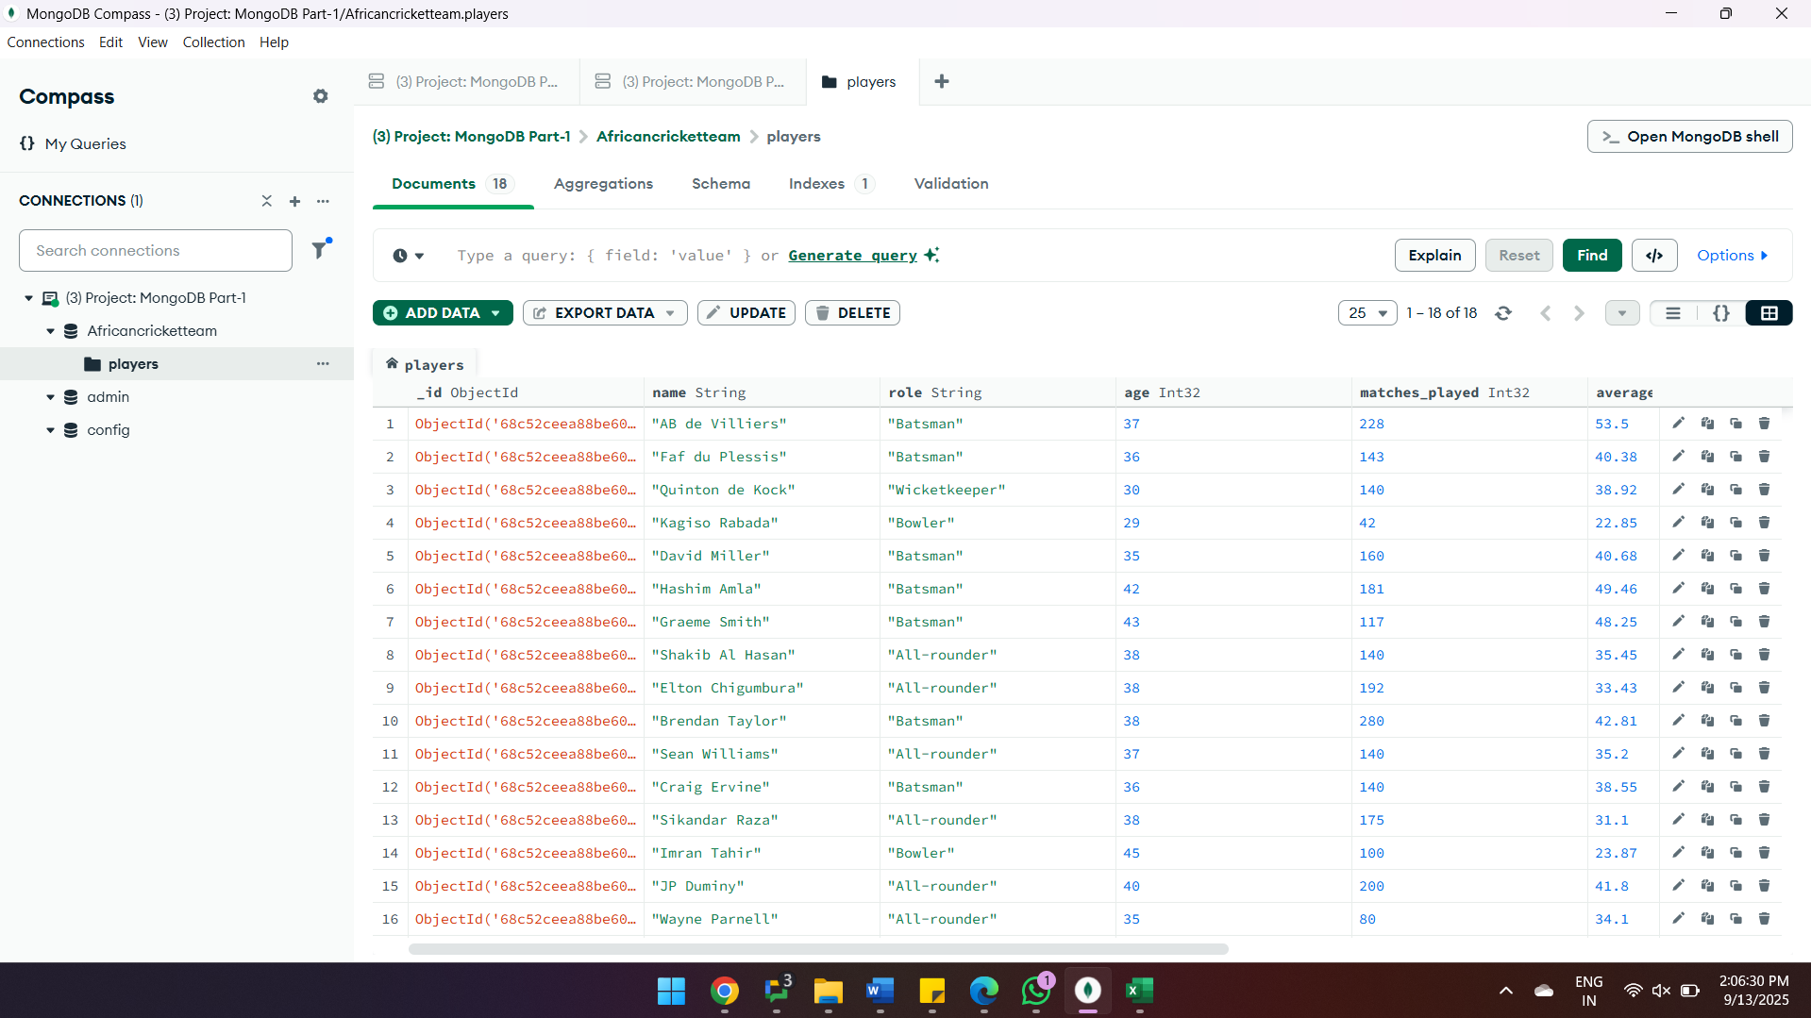

**Query 1: Find all players who are Batsmen.**

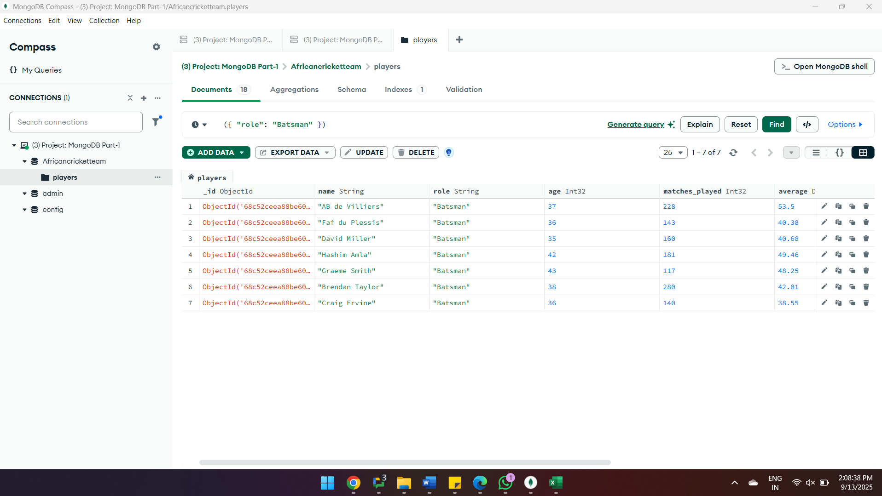

**Query 2: Find all players who have played more than 100 matches.**

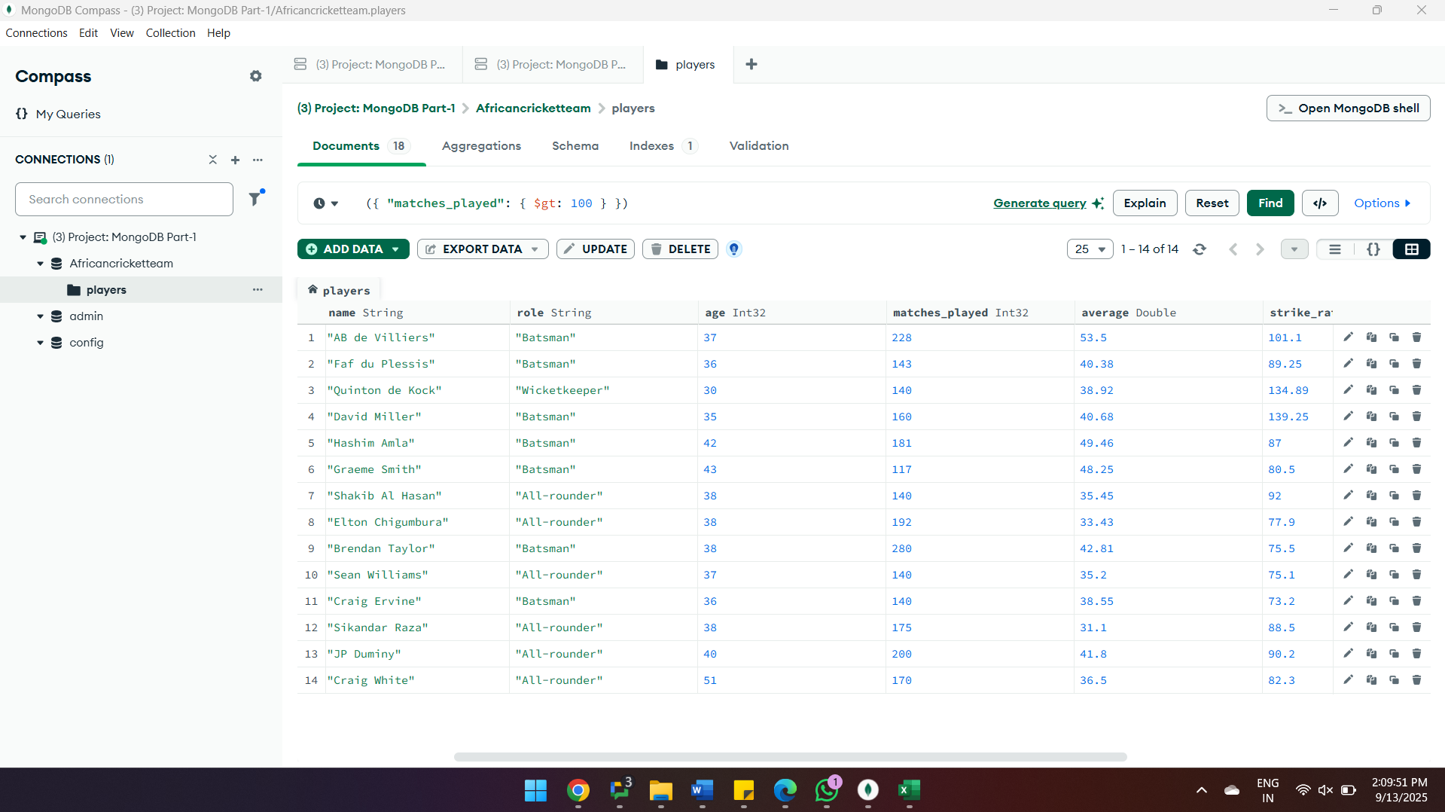

**3.Query to Find the Player with the Highest Batting Average:**

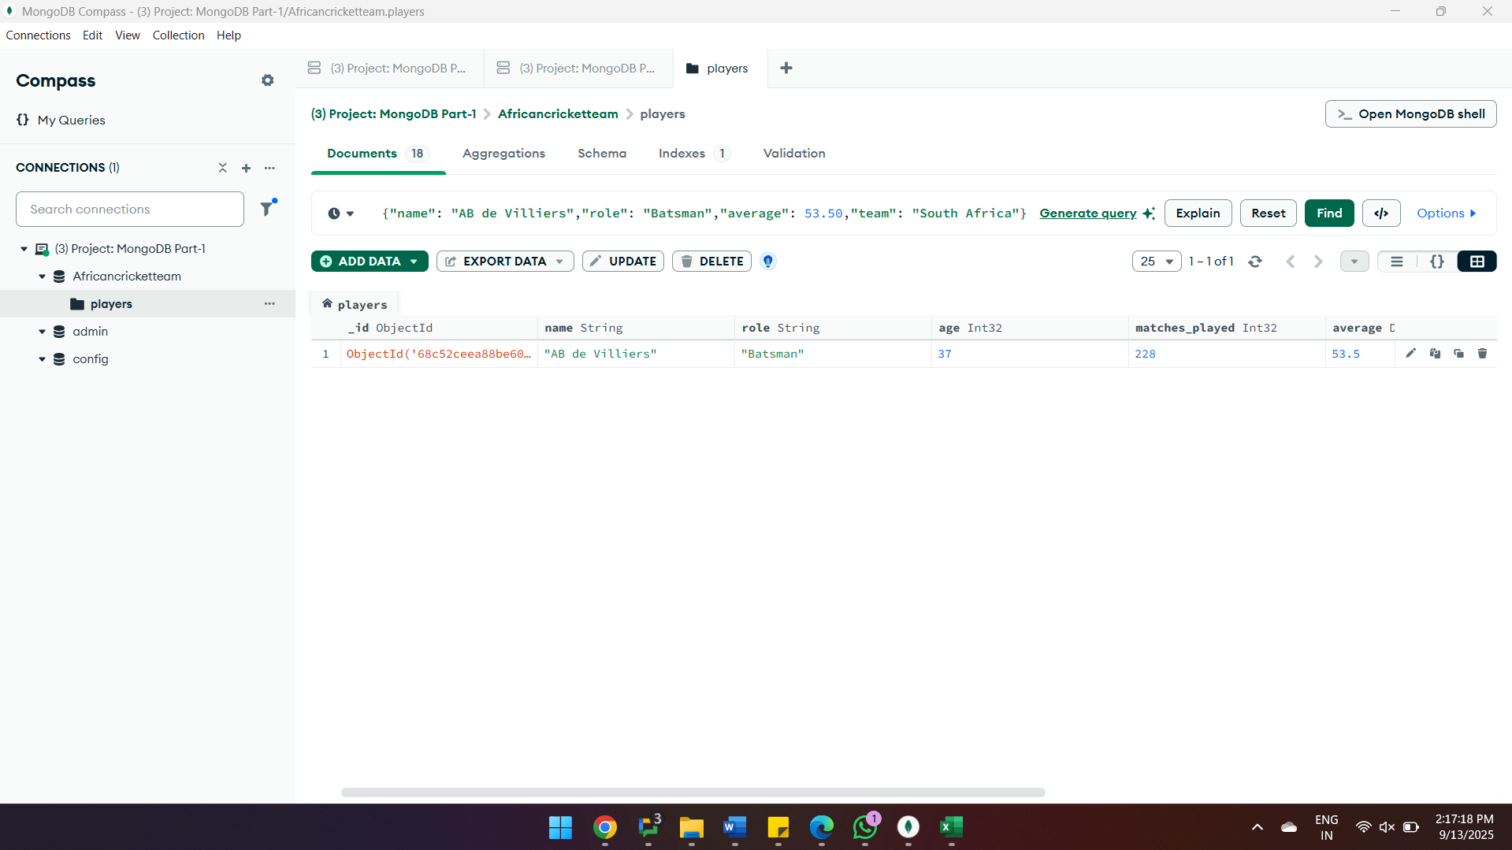

**Query 4: Find all players who are older than 35 years.**

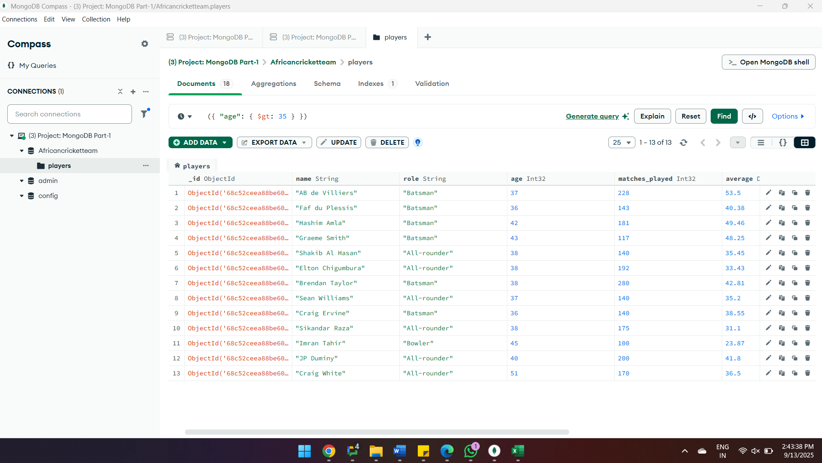

**Query 5: Find all players who are from "South Africa" or "Zimbabwe".**

